

Stochastic modeling of the risk factors of the interest term structure using single factor models

**Valentin DIMITROV**

**Boubker KITANE**

**Année universitaire 2017-2018**

Contents

Introduction 3

Oldrich Vasicek – An Equilibrium Characterization of the Term Structure 5

John Cox, Jonathan Ingersoll, Stephen Ross – A Theory of the Term Structure of Interest Rates 8

John Hull, Alan White – Pricing Interest-Rate-Derivative Securities 11

References 13

# Introduction

The term structure of interest rates is the yield curve which represents the yield of debt securities considered as default-free relative to their time to maturity. Most notably, it contains premiums accounting for the variability and expectations of future inflation and future spot rates (term premium). Default-free securities are generally very liquid, hence the liquidity premium is negligible.

|  |  |  |  |  |  |  |  |  |  |  |  |
| --- | --- | --- | --- | --- | --- | --- | --- | --- | --- | --- | --- |
| M | 1 Mo | 3 Mo | 5 Mo | 1 Yr | 2 Yr | 3 Yr | 5 Yr | 7 Yr | 10 Yr | 20 Yr | 30 Yr |
| R | 1.14% | 1.27% | 1.45% | 1.62% | 1.78% | 1.90% | 2.13% | 2.28% | 2.37% | 2.58% | 2.76% |

*M – time to maturity R – interest rate*

*Data source:* [*U.S. Department of the Treasury*](https://www.treasury.gov/resource-center/data-chart-center/interest-rates/Pages/TextView.aspx?data=yieldYear&year=2017)

An explanation of the term structure should provide a method of prediction or fitting which establishes a connection between interest rates of bonds with different maturities.

Robert Merton (1973) was the first one to propose a single factor model for the term structure of interest rates. Due to modelling the evolution of the spot rate as geometric Brownian motion, Merton’s model allows for negative interest rates, assumes that volatility and the risk premium are constant. This model serves as base for subsequent more complex single factor models.

Later on, multi-factor models have been proposed which aim to improve modelling of the term structure of interest rates by introducing factors such as stochastic drift, instantaneous inflation rate, long term rate or volatility of some sort.

There are 3 main hypothesis which aim to explain the relationship between interest rates of risk-free bonds with various maturities.

* **Expectation hypothesis** – Investors’ expectations of future spot rates determine the term structure. Bond pricing is done on the principle that the implied forward rate should be an unbiased estimator of the future prevailing spot rate. A few variations of this hypothesis exist.
* **Liquidity preference hypothesis** – Investors are risk-averse therefore have a preference for short-term bonds. On the other hand, long-term ones are preferred by borrowers. As result, a premium is incorporated in the price depending on the time to maturity. An important consequence is that the expected return from a buy and hold strategy will be higher than the expected return for a roll-over strategy. The resulting term structure of interest rates should be upward sloping.
* **Preferred habitat hypothesis** – Market participants are assumed to have individual preferences regarding time to maturity. They are willing to change their “habitat” range if a sufficient premium is offered. Depending on market conditions, the risk premia associated with bonds of various maturities can be positive, negative or none. Therefore, the term structure of interest rates can take any shape.

Only the risk-neutral versions of the 3 models are presented in this paper.

# Oldrich Vasicek – An Equilibrium Characterization of the Term Structure

In the Vasicek model, the evolution of spot interest rates is characterized by a stochastic mean-reversion behavior towards a fundamental long-term value. This can be considered as theoretically as consistent with equilibrium economic models. In reality, high interest rates impede economic activity while low interest rates reduce savings and investment. Assuming a reasonable fundamental value is congruent with reality no matter how it is derived.

More precisely, the Vasicek model is an application of the Ornstein-Uhlenbeck stochastic process which

is an asymptotically stationary and distributed around a long term value.

The Vasicek model conforms to the expectation hypothesis, the liquidity preference hypothesis and the preferred habitat hypothesis.

There are 3 main hypotheses underlying the model:

* The spot interest rate follows a diffusion process
* The price of a discount bond depends only on the spot rate over its term
* The market is efficient (there is no possibility of arbitrage)

The Vasicek model assumes that the spot interest rate behaves like a first-order autoregressive process:

$$AR\left(1\right): r_{t}=α+βr_{t-1}+σε_{t} where α=ab ; β=1-a ; ε_{t}\sim N\left(0,1\right) ; t∈\left\{0,1,…,n\right\}$$

The latter equation could be rewritten as:

$$r_{t}=ab+\left(1-a\right)r_{t-1}+σε_{t} \left(1\right)$$

Therefore, the evolution of the spot interest is thus determined by the following diffusion process:

$$dr_{t}=a\left(b-r_{t-1}\right)dt+σdW_{t} \left(2\right)$$

This form is most often used to refer to the Vasicek model.

Where:

* $a$– convergence speed factor
* $b$– convergence limit (fundamental value of the spot rate; could be time dependent - $b\left(t\right)$)
* $σ$– instantaneous volatility or randomness impacting the evolution of the interest rate
* $W_{t}$– Wiener process
* $a\left(b-r_{t}\right)$– expected instantaneous change of the spot rate
* $σdW_{t}$– exogenous shocks impacting the spot rate

Another transformed form of the model is:

$$r_{T}=r_{0}e^{-aΔt}+b\left(1-e^{-aΔt}\right)+σ\int_{0}^{T}{e^{-at}dW_{t}} where t∈\left[0,T\right] ; Δt=t_{T}-t_{0} \left(3\right)$$

This one makes easy to obtain the expected value and the variance of the process which are:

$$E\left[r_{t}|r_{s}\right]=r_{s}e^{-aΔt}+b\left(1-e^{-aΔt}\right) \lim_{t→∞}{E\left[r_{t}|r_{s}\right]}=b$$

$$V\left[r_{t}|r_{s}\right]=\frac{σ^{2}}{2a^{2}}\left(1-e^{-2aΔt}\right) \lim_{t→∞}{V\left[r_{t}|r_{s}\right]}=\frac{σ^{2}}{2a^{2}}$$

Where $0≤s≤t≤T$

The process is asymptotically stationary around the fundamental value $b$. The long-term variance shows that $a$ and $σ$ partially counteract each other’s effect. Increase in $a$ represents a faster convergence speed which could offset a non-proportional increase in $σ$.

The biggest drawback of this model is that the interest rates may become negative. This tendency is considered to be unrealistic nor desirable in most cases. In addition, it is impossible to fit an initial yield curve precisely, because the only parameter that can be used for calibration of the model is the volatility.

**Simulation of the model and pricing of a zero-coupon bond using R**

In order to perform simulations of the Vasicek model, equation $\left(3\right)$ can be approximated in discrete terms by:

$$r_{t}=r_{t-1}e^{-aΔt}+b\left(1-e^{-aΔt}\right)+σ\sqrt{\frac{1-e^{-2aΔt }}{2a}}×ε_{t} \left(4\right)$$

The price of a zero-coupon bond with maturity $T$ at time $t∈\left[0,T\right]$ can be obtained by solving:

Where:

The following R code aims to replicate the term structure of interest rates shown in the introduction of this paper as well as to simulate the price of a zero-coupon bond with a 30-year maturity. The parameters a and $σ$ were chosen in a semi-arbitrary manner. Techniques to estimate these parameters rigorously do exist. The following simulations represent an indicative example.

period = 30 # 1-year period

T = period*250 # number of steps in terms of work days

step = period/T # numerical representation of a step

timesequence = seq(0,period,length.out = T) #time range (x axis)

# Simulation of a Vasicek/Ornstein-Uhlenbeck process

a = 0.1 # convergence speed factor

b = 0.0276 # convergence limit (fundamental value of the spot rate)

sigma = 0.005 # annualized instantaneous volatility

r_0 = 0.01 # initial value of the interest rate

r_t = timesequence #initialization of r_t

r_t[1] = r_0 # setting of the initial value of the vector

epsilon = rnorm(T) #vector of 300 normally distributed values

#w = cumsum(epsilon) # vector containing the state of the Wiener process at each time value

# Vasicek term structure simulation

for (i in 2:T){

r_t[i]=r_t[i-1]*exp(-a*step)+b*(1-exp(-a*step))+sigma*sqrt((1-exp(-2*a*step))/2*a)*epsilon[i]

}

plot(timesequence,r_t,type='l',col='red', ylab = "Interest Rate", xlab = "Years to maturity",main = "Vasicek model realization")

B_t_T=timesequence #initialization of r_t

A_t_T=timesequence #initialization of r_t

P_t_T=timesequence #initialization of r_t

# Vasicek price of a discount bound

for (i in 2:T){

B_t_T[i] = (1-exp(-a*(T-timesequence[i])))/a #due to the high number of steps, the exponential term is practically 0

A_t_T[i] = exp((b-sigma^2/(2*a^2))*(B_t_T[i]-30+timesequence[i])-sigma^2*B_t_T[i]^2/4*a)

P_t_T[i] = A_t_T[i]*exp(-r_t[i]*B_t_T[i])

}

P_t_T[1]=P_t_T[2]

plot(timesequence,P_t_T,type='l',col='red', ylab = "Price of a discount bond", xlab = "Years to maturity",main = "Discount bond - Vasicek model")

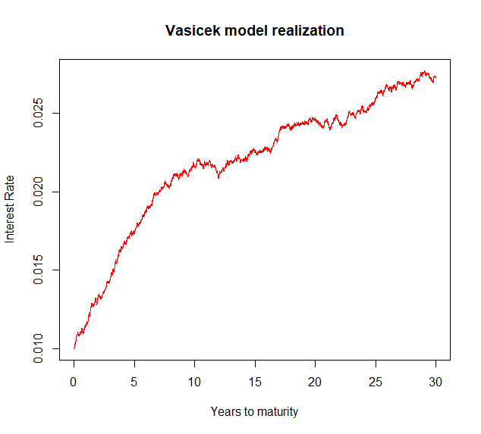 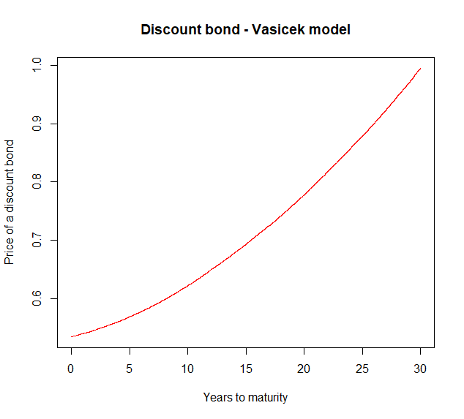

# John Cox, Jonathan Ingersoll, Stephen Ross – A Theory of the Term Structure of Interest Rates

The Cox-Ingersoll-Ross model is an extension of the Vasicek model. Unlike Vasicek, the Cox-Ingersoll-Ross (CIR) model is based on an intertemporal general equilibrium model (meaning that it is derived from a hypothetical structure of the economy). The CIR model conforms to the expectation hypothesis and the liquidity preference hypothesis.

The derived diffusion process of the spot interest rate is:

$$dr_{t}=a\left(b-r_{t}\right)dt+σ\sqrt{r_{t}}dW_{t} \left(8\right)$$

The drift factors $a\left(b-r_{t}\right)$ remains the same compared to the Vasicek model, but the diffusion parameter is different. The addition of $\sqrt{r_{t}}$ results in larger deviations when the spot rate is high, thus increasing the variance of the spot rate and in lower deviation when the spot rate is low, thus reducing the variance of the spot rate. The intuition would be that spot rates on the market are very low, volatility tends to be also very low.

The $r\left(t\right)$ will never become negative if the initial spot interest rate is positive and $2ab>σ^{2}$ because the upward drift would be bigger than a negative shock. This is attributed to the mean-reverting drift that tends to pull $r\left(t\right)$ towards the long-run average $b$ as well as to the diminishing volatility due to $r(t)$ being closer to zero.

The value of the spot rate at time $t$ is given by:

$$r_{t}=r_{0}e^{-aΔt}+b\left(1-e^{-aΔt}\right)+σ\int_{0}^{T}{\sqrt{r_{t}}e^{-at}dW_{t}} where t∈\left[0,T\right] ; Δt=t_{T}-t_{0} \left(9\right)$$

$$E\left[r_{t}|r_{s}\right]=r_{s}e^{-aΔt}+b\left(1-e^{-aΔt}\right) \lim_{t→∞}{E\left[r_{t}|r_{s}\right]}=b$$

$$V\left[r_{t}|r_{s}\right]=r_{s}\frac{σ^{2}}{a}\left(e^{-aΔt}-e^{-2aΔt}\right)+\frac{σ^{2}}{2a}{\left(1-e^{-2aΔt}\right)}^{2} \lim_{t→∞}{V\left[r_{t}|r_{s}\right]}=\frac{σ^{2}}{2a}$$

The expected value of the spot rate is the same as Vasicek due to the mean-reversion behavior. The variance is obviously modified due to the additional of $\sqrt{r_{t}}$. The asymptotic value of the first two moments remain the same.

The CIR model removes the probability of having negative interest rates, but retains the second main drawback of the Vasicek model - it is impossible to fit an initial yield curve precisely, because the only parameter that can be used for calibration of the model is the volatility.

**Simulation of the model and pricing of a zero-coupon bond using R**

In order to perform simulations of the CIR model, equation $\left(6\right)$ can be approximated in discrete terms by:

$r_{t}=r_{t-1}e^{-aΔt}+b\left(1-e^{-aΔt}\right)+σ\sqrt{r_{t}}\sqrt{\frac{1-e^{-2aΔt }}{2a}}×ε_{t} \left(10\right)$

The price of a zero-coupon bond with maturity $T$ at time $t∈\left[0,T\right]$ can be obtained by solving:

Where:

The following R code aims to replicate the term structure of interest rates shown in the introduction of this paper as well as to simulate the price of a zero-coupon bond with a 30-year maturity. The parameters a and $σ$ were chosen in a semi-arbitrary manner and are the same as the ones used for the Vasicek model. Techniques to estimate these parameters rigorously do exist. The following simulations represent an indicative example.

period = 30 # 1-year period

T = period*250 # number of steps in terms of work days

step = period/T # numerical representation of a step

timesequence = seq(0,period,length.out = T) #time range (x axis)

# Simulation of a Vasicek/Ornstein-Uhlenbeck process

a = 0.1 # convergence speed factor

b = 0.0276 # convergence limit (fundamental value of the spot rate)

sigma = 0.005 # annualized instantaneous volatility

r_0 = 0.01 # initial value of the interest rate

r_t = timesequence #initialization of r_t

r_t[1] = r_0 # setting of the initial value of the vector

epsilon = rnorm(T) #vector of 300 normally distributed values

#w = cumsum(epsilon) # vector containing the state of the Wiener process at each time value

# CIR term structure simulation

for (i in 2:T){ #realization of the exact solution of the CIR model

r_t[i]=r_t[i-1]*exp(-a*step)+b*(1-exp(-a*step))+sigma*sqrt((1-exp(-2*a*step))/2*a)*sqrt(r_t[i-1])*epsilon[i]

}

plot(timesequence,r_t,type='l',col='red', ylab = "Interest Rate", xlab = "Years to maturity",main = "CIR model realization")

B_t_T=timesequence #initialization of r_t

A_t_T=timesequence #initialization of r_t

P_t_T=timesequence #initialization of r_t

# CIR price of a discount bound

h=sqrt(a^2+2*sigma^2)

for (i in 2:T){ #realization of the exact solution of the Vasicek model

B_t_T[i] = 2*exp(h*(T-timesequence[i])-1)/(2*h+(a+h)*exp(h*(T-timesequence[i])-1))

A_t_T[i] = (2*h*exp((a+h)*(T-timesequence[i])/2)/(2*h+(a+h)*exp(h*(T-timesequence[i])-1)))^(2*a*b/sigma^2)

P_t_T[i] = A_t_T[i]*exp(-r_t[i]*B_t_T[i])

}

P_t_T[1]=P_t_T[2]

plot(timesequence,P_t_T,type='l',col='red', ylab = "Price", xlab = "Years to maturity",main = "Discount bond - CIR model")

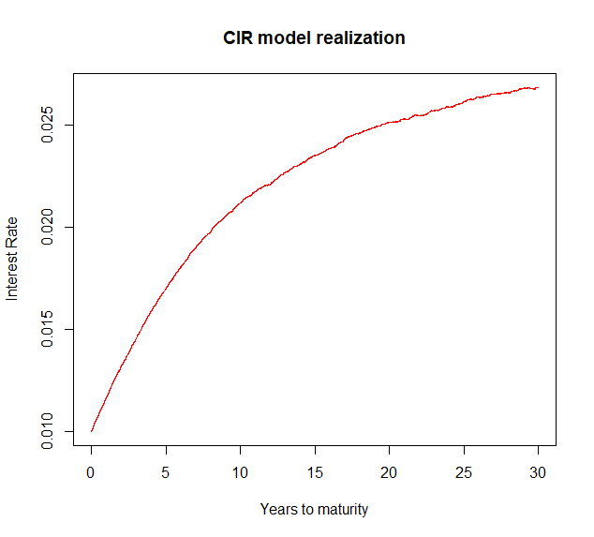

Compared to the Vasicek model simulation, the CIR simulation demonstrates a smoother trajectory due to its reduced variance.

Note that the code presented above for calculating the price of a discount bond is not functionally correct.

# John Hull, Alan White – Pricing Interest-Rate-Derivative Securities

John Hull and Alan White (HW) begin their article with a generalization of the diffusion process of the spot interest rate of the Vasicek and CIR models:

$$dr_{t}=a\left(b-r_{t}\right)dt+σr_{t}^{β}dW_{t} \left(15\right)$$

* Vasicek: $β=0 → dr_{t}=a\left(b-r_{t}\right)dt+σdW_{t}$
* CIR: $β=0.5 → dr_{t}=a\left(b-r_{t}\right)dt+σ\sqrt{r_{t}}dW_{t}$

In these versions of the models, it is assumed that the term premiums (measuring the rise of the expected return for one unit of risk) denoted as $λ$ are equal to 1 (therefore $λσdW_{t}=σdW_{t}$). This assumption will be used for the rest of this paper.

Ho and Lee (1986) pioneered an approach to make an interest-rate model consistent with any specified initial term structure. The HW models represent a mix of the ideas from the continuous version of the Ho and Lee model with the Vasicek and CIR models. The general form of the HW models is:

$$dr_{t}=\left[θ\left(t\right)+a\left(t\right)\left(b-r\right)\right]dt+σ\left(t\right)r_{t}^{β}dW_{t} \left(16\right)$$

Where the additions to the Vasicek/CIR model are:

* $θ\left(t\right)$– time-dependent drift
* $a\left(t\right)$– time-dependent convergence speed factor
* $σ\left(t\right)$– time-dependent volatility factor

The economic reasoning supporting the time-dependence of the drift, the convergence speed factor and the volatility factor is based on the cyclical nature of market economies. It is reasonable establish a relationship between the market’s expectations and time as the former vary throughout economic cycles. For example, the announcement of a monetary policy or forecasts of macroeconomic variables can cause significant market movement. The obvious consequence would be that the three variables mentioned above should be functions of time.

In this form of the model, a drift rate is imposed to the otherwise converging dynamic.

The generalized form can be rewritten as:

$$dr_{t}=a\left(t\right)\left(\frac{θ\left(t\right)}{a\left(t\right)}+b-r_{t-1}\right)dt+σ\left(t\right)r_{t}^{β}dW_{t} \left(17\right)$$

In this form of the model, the long-term level $\frac{θ\left(t\right)}{a\left(t\right)}+b$ is a function of time.

$$r_{t}=r_{0}e^{-aΔt}+b\left(1-e^{-aΔt}\right)+\int_{0}^{T}{θ\left(t\right)dt}+σ\int_{0}^{T}{r_{t}^{β}e^{-at}dW_{t}} \left(18\right)$$

We are going the consider the one-factor version of the HW model where only $θ$ is time-dependent and includes $b$ (i.e. $b$ is omitted). $a$ and $σ$ are constants.

**Model 1: Extended Vasicek model $\left(β=0\right)$**

$$dr_{t}=\left[θ\left(t\right)-ar_{t-1}\right]dt+σdW_{t} \left(18\right)$$

$$E\left[r_{t}|r_{s}\right]=r_{s}e^{-aΔt}+\frac{θ}{a}\left(1-e^{-aΔt}\right) \lim_{t→∞}{E\left[r_{t}|r_{s}\right]}=b$$

$$V\left[r_{t}|r_{s}\right]=r_{s}\frac{σ^{2}}{a}\left(e^{-aΔt}-e^{-2aΔt}\right)+\frac{σ^{2}}{2a}{\left(1-e^{-2aΔt}\right)}^{2} \lim_{t→∞}{V\left[r_{t}|r_{s}\right]}=\frac{σ^{2}}{2a}$$

**Model 2: Extended CIR Model $\left(β=0.5\right)$**

$$dr_{t}=\left[θ\left(t\right)-ar_{t-1}\right]dt+σ\sqrt{r_{t}}dW_{t} \left(18\right)$$

$$E\left[r_{t}|r_{s}\right]=r_{s}e^{-aΔt}+\frac{θ}{a}\left(1-e^{-aΔt}\right) \lim_{t→∞}{E\left[r_{t}|r_{s}\right]}=b$$

The addition of $\sqrt{r_{t}}$ leads to lower variance of the process. Consequently $θ\left(t\right)$ in this model is smaller than the same term in the extended Vasicek model.

# References

O. Vasicek (1977). [*An Equilibrium Characterization of the Term Structure*](https://drive.google.com/file/d/0B7n2zkcK6XwqUnZpUGNWcERCOUE/view)*.*

J. Cox, J. Ingersoll, S. Ross (1985). [*A Theory of the Term Structure of Interest Rates*](https://drive.google.com/file/d/0B7n2zkcK6XwqdFpsdGtpRmc4WTA/view)*.*

T. S. Y. Ho, S. Lee (1986). *Term Structure Movements and Pricing Interest Rate Contingent Claims.*

J. Hull, A. W. (1990). [*Pricing Interest-Rate-Derivative Securities*](https://drive.google.com/file/d/10YCMEOaNJQAnIK3KU6I59LFqZRC__qa7/view)*.*

J.Hull, A. White.(1993). *One factor interest rate models and the valuation of interest rate derivative securities.*

R. Gibson, F.-S. LHabitant, D. Talay (2001). [*Modeling the term structure of interest rates: a review of the literature*](http://www2.risklab.ch/ftp/papers/TermStructureSurvey.pdf)

Gutiérrez, R. M. (2008). *Modelling the term structure of interest rates: a literature review*

Toke, I. M. (2011). [Modèles stochastiques de taux d'intérêts](http://www.ressources-actuarielles.net/EXT/ISFA/fp-isfa.nsf/2b0481298458b3d1c1256f8a0024c478/a7d2d3a2fce9a337c125783d002eef6a/$FILE/InterestRatesModels-LectureNotes2011.pdf)